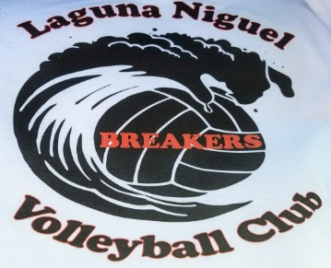

U14-U16 Summer Session 2022
June 27th – August 31st

Practices held at McDowell School
Mondays, Wednesdays & Fridays – 5:30pm – 7:30pm

OCVH Tournaments
To be Announced……
********************** Registration Form ************************
My child ______________________________ has permission
to participate in the Laguna Niguel Breakers Volleyball Club.

Parent Name ____________________________ Phone _____________
Parent Signature _____________________________ Date __________
Cost: $250 - Please make checks payable to:
Scott Myers or Venmo (ScottMyers@Scott-Myers-55)

